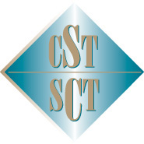

October 6-7, 2025

This is to certify that / Le présent certificat atteste que

Name/Nom:
Attended the 2025 CST Fellows Symposium
At The Westin Bayshore, Vancouver, BC

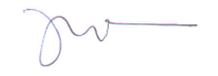
Dr. Jagbir Gill
President, Canadian Society of Transplantation
114 Cheyenne Way●Ottawa●ON●K2J 0E9●Tel:(877) 968-9449●Fax: (613) 491-0073
admin@cst-transplant.ca ●www.cst-transplant.ca

