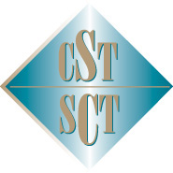

October 6-10, 2025

This is to certify that / Le présent certificat atteste que

Name/Nom:
Attended the 2025 CST Annual Scientific Meeting
At The Westin Bayshore, Vancouver, BC
Hours / heures: (max. 20.5)

This event is an Accredited Group Learning Activity (Section 1) as defined by the Maintenance of Certification Program of the Royal College of Physicians and Surgeons of Canada and approved by the Canadian Association of General Surgeons. You may claim a maximum of 20.5 hours.

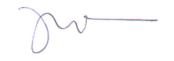
Dr. Jagbir Gill
President, Canadian Society of Transplantation
114 Cheyenne Way●Ottawa●ON●K2J 0E9●Tel:(877) 968-9449●Fax: (613) 491-0073
admin@cst-transplant.ca ●www.cst-transplant.ca

